***About Tesla***

* **What was Tesla ?**

**Tesla, Inc.** is an American multinational [automotive](https://en.wikipedia.org/wiki/Automotive) and [clean energy](https://en.wikipedia.org/wiki/Clean_energy) company headquartered in [Austin, Texas](https://en.wikipedia.org/wiki/Austin,_Texas).

Tesla designs and manufactures [electric vehicles](https://en.wikipedia.org/wiki/Electric_vehicle) ([electric cars](https://en.wikipedia.org/wiki/Electric_car) and [trucks](https://en.wikipedia.org/wiki/Electric_truck)), battery [energy storage](https://en.wikipedia.org/wiki/Energy_storage) from home to [grid-scale](https://en.wikipedia.org/wiki/Grid-scale_storage), [solar panels](https://en.wikipedia.org/wiki/Solar_panel) and [solar roof tiles](https://en.wikipedia.org/wiki/Solar_roof_shingles), and related products and services.

Tesla is one of the [world's most valuable companies](https://en.wikipedia.org/wiki/List_of_public_corporations_by_market_capitalization) and remains the world's most valuable automaker with a [market capitalization](https://en.wikipedia.org/wiki/Market_capitalization) of more than US$550 billion.

In 2021, the company had the most worldwide sales of [battery electric vehicles](https://en.wikipedia.org/wiki/Battery_electric_vehicle) and [plug-in electric vehicles](https://en.wikipedia.org/wiki/Plug-in_electric_vehicle), capturing 21% of the battery-electric (purely electric) market and 14% of the plug-in market (which includes [plug-in hybrids](https://en.wikipedia.org/wiki/Plug-in_hybrid)).

Through its subsidiary [Tesla Energy](https://en.wikipedia.org/wiki/Tesla_Energy), the company develops and is a major installer of [photovoltaic systems](https://en.wikipedia.org/wiki/Photovoltaic_system) in the United States.

Tesla Energy is also one of the largest global suppliers of battery energy storage systems, with 3.99 [gigawatt-hours](https://en.wikipedia.org/wiki/Gigawatt-hours) (GWh) installed in 2021.

* **Company size (Financial, Employees, Stakeholders and Investors etc.)**

* **What was their revenue model ?**

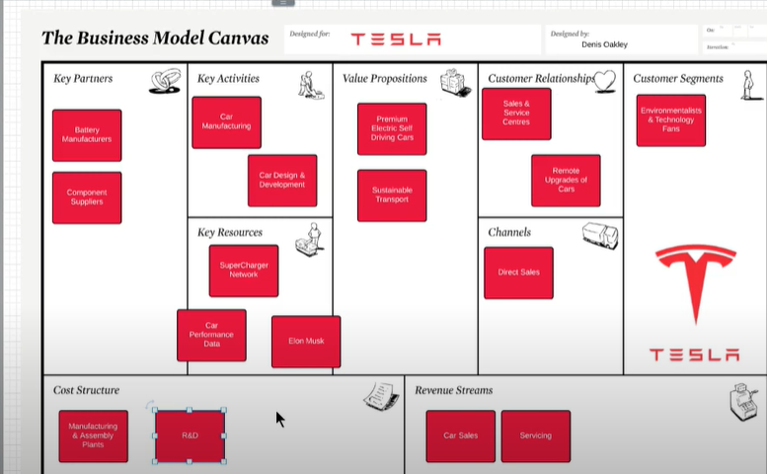

Tesla has an established brand in the market for is recognized for the electrical vehicle. The company’s Revenue Model includes three major components which are Sales of Electric Vehicles, Servicing and Charging of  Vehicles.

Tesla is using Direct Sell methods in which a company sells its vehicles on company-owned showroom and supply through its international distribution channel.

The company also has a self-service online store. The company also owned Service Centers in which the company provides service for Electric Vehicles.

Tesla also creates a super Network of Charger in which Drivers fully charger for 30 minutes in free.

The reason behind these Charging Networks is people can charge their vehicles while on the go and it will help them to adopt electrical vehicles.

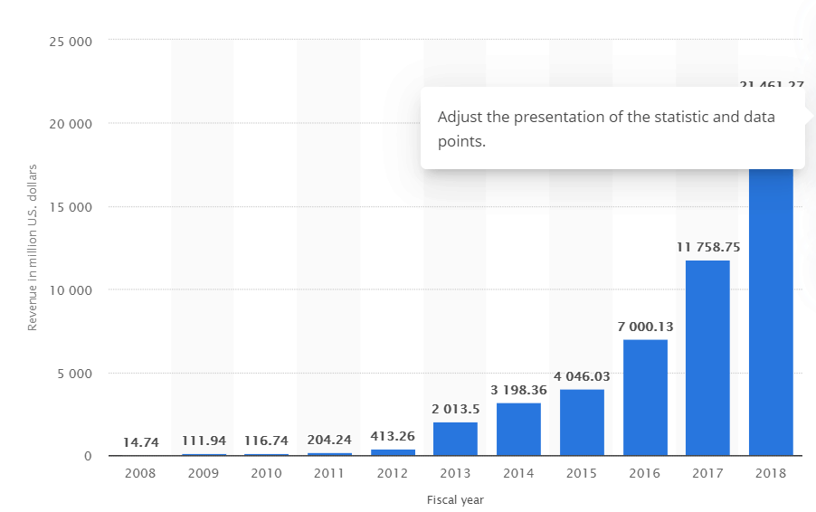

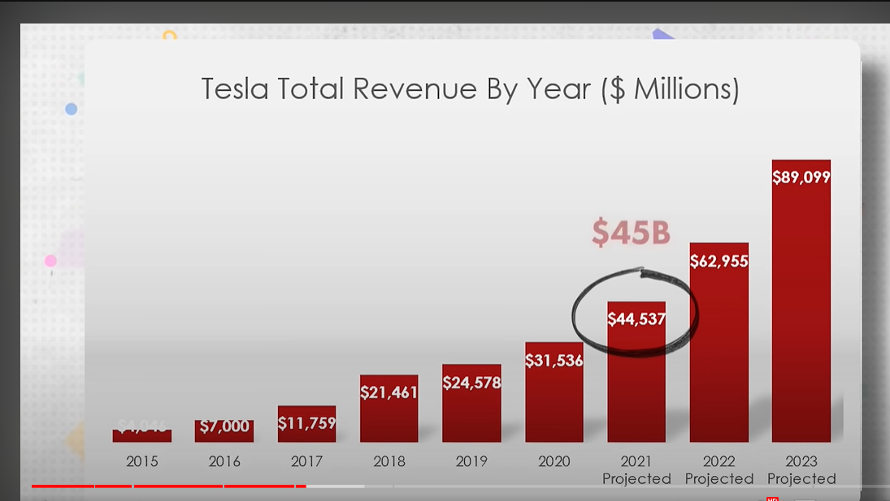

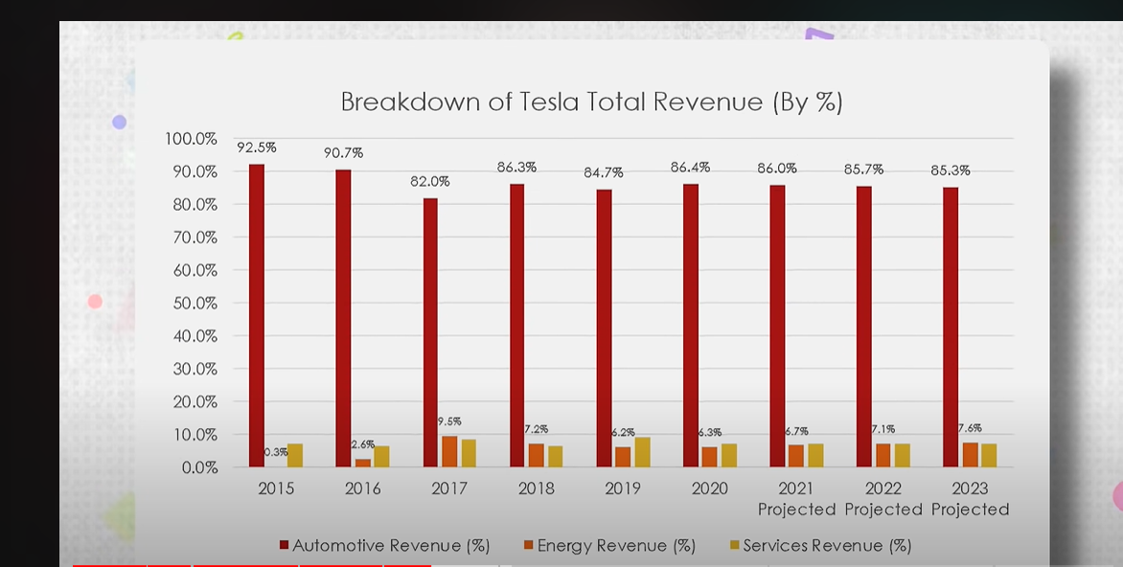

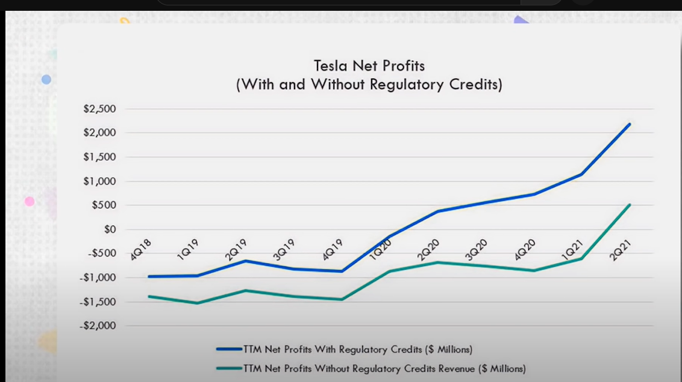

* **Customer analysis**
* **The Model S**

|  |  |
| --- | --- |
| **Buyer Profile** |  |
| Male: | 83.9% |
| Female: | 16.1% |
| Income under $50,000: | 5.7% |
| Income $50,000-$99,999: | 17.2% |
| Income over $100,000: | 77.3% |
| 18-44 yrs. old: | 33.2% |
| 45-64 yrs. old: | 50.6% |
| 65+ yrs. old: | 16.2% |

* **Product Analysis**

**SWOT analysis of Tesla Motors:-**

**High Market Valuation:**

The market valuation of [Tesla](https://notesmatic.com/2019/07/tesla-swot-analysis-2019/) has grown very fast in recent years. Its market cap has surged to around $400 billion in 2020, which is the highest of all the automobile brands globally.

Its shares climbed very fast in August 2020, making Tesla the [seventh-largest](https://www.marketwatch.com/story/tesla-passes-visa-to-become-seventh-largest-us-company-by-market-cap-2020-08-31) US-based company for a short period. In the September- October period, the shares of Tesla declined again. However, the company is still a lot ahead of other major automakers like VW and Toyota in terms of market capitalization.

Tesla may still not be the largest automobile company in the world regarding car production and sales. Still, the overall valuation of the company has grown much higher than its rivals. In the last few months only, Tesla stocks have [climbed insanely](https://www.latimes.com/business/story/2020-07-22/why-the-stock-market-is-so-high-and-tesla-even-higher) and steadily.

**Technological Innovation:**

One of the main factors driving fast growth in popularity and sales of Tesla cars is the company’s focus on technological innovation. The automobile industry is marked by heavy competition, but Tesla belongs to a distinct class of automakers. It makes only Electrical vehicles and that too for the higher end market. Tesla cars are great in terms of product quality, design, performance, and passenger safety. The company spent around $1.34 billion on research and development in 2019. Apart from these things, Tesla cars are loaded with technology. These cars’ maintenance costs are very low because of the lower number of parts used inside them, which more than makes up for the one-time purchasing costs. Autodrive and other technologies make these cars safer and performance-wise superior to the other cars on the roads. The Model 3 earned the [2019 Top Safety Pick](https://www.usatoday.com/story/money/cars/2019/09/19/tesla-model-3-iihs-top-safety-pick/2354457001/) award from IIHS.  It achieved a good performance in all six IIHS crash tests. The award is an endorsement of Tesla’s safety systems that Elon Musk often touts in the media and on social media. Overall, Tesla cars offer a superior riding experience compared to most cars on the road, and therefore they easily stand out from the competition. It has resulted from the company’s consistent focus on technological innovation over time. The company also provides regular software updates for its cars. Tesla’s cars also offer a superior battery range compared to the rival EVs and hybrids on the roads.

**Fast sales growth:**

With the release of Model 3, Tesla sales have grown worldwide. The company has experienced a sharp increase in its vehicle sales in 2019, and despite the decline in demand due to the pandemic, it has retained a lot of its growth momentum. In 2019, the company delivered around 3,67000 units, which was a sharp rise from around 2,45000 in 2018. The pandemic has led to a sharp decline in automobile sales worldwide. However, despite the pressure in demand, Tesla has seen its sales in the second quarter of 2020 rise compared to the first. While overall sales in the first half of 2020 were lower than the previous year, Tesla has still proved itself a lot more resilient in the face of the pandemic than all the other automobile brands in the industry.

According to [Statista](https://www.statista.com/statistics/502208/tesla-quarterly-vehicle-deliveries/#:~:text=How%20many%20Tesla%20vehicles%20were,three%20months%20of%20the%20year.), Tesla delivered around 90,650 vehicles between April and June in 2020, which was around 2250 units higher than the previous quarter. It is lower than in the same quarter in the previous year when the company had shipped more than 95,000 units. Still, considering that the automobile industry is passing through a challenging phase, Tesla’s performance counts as nothing less than rock solid. In the light of low automobile demand overall and shrinking sales of nearly all automobile brands, Tesla’s sales in the second quarter of 2020 can be seen as a big success. In the second quarter of 2020, Tesla delivered more than 80,000 of Model 3 and Model Y. Since Tesla introduced the Model 3 in the third quarter of 2017, its sales have continued to soar. However, in the third quarter of 2020, the company has experienced impressive sales growth. Its total sales for the third quarter of 2020 were around 40% higher than the sales during the same period in the previous year. According to sources, Tesla sold more than 64,000 units in the US in the third quarter of 2020 compared to around 52,000 units during the same period in the previous year. Given how automobile demand has crashed due to the pandemic, Tesla’s performance is nothing less than stellar.

**Strong performance of Tesla Vehicles:**

Based on overall performance, Tesla vehicles are classified among the best on the roads. Apart from zero-emission of their vehicles and their superior battery range, they are also among the safest and require nearly no maintenance than the other vehicles. Its model S can drive [roughly 370 miles](https://www.washingtonpost.com/technology/2020/01/10/tesla-battery-range/) without stopping for a charge. This is more than 50% higher than the range that competing cars from brands like Chevrolet, Nissan, or Jaguar offer. Their cars can make up to 240 miles at best on a single charge, which is nothing compared to Tesla’s Model S. It marks a major difference for Tesla and is also the primary reason behind the superior demand for its SUVs. Tesla cars are also enjoying superior safety ratings overall. These cars use fewer parts overall compared to a regular car due to which the maintenance costs for the owner and technical complications are also lower. These factors have led to higher satisfaction for the Tesla car owners.

**Leading position in the US and China EV markets:**

Tesla is the leading EV brand in the world. However, its position is the strongest in the US and [China markets](https://notesmatic.com/strategic-importance-of-china-for-tesla-motors/). Even during the pandemic when the demand for automobiles has continued to fall around the world, the company is enjoying stronger sales and growth.

Tesla has quickly risen to the top in terms of EV sales in China since it started production in its Shanghai manufacturing facility. According to Counterpoint Research, Tesla accounted for around 23% of EV sales in China in June 2020. On the other hand, in the US, the company is enjoying even stronger sales in 2020 despite the slowdown due to the pandemic. While it sold fewer cars in the first and second quarters of 2020 compared to the previous year, sales surged again in the third quarter of 2020 compared to the same period in the previous year. In the third quarter of 2020, Tesla cars’ sales were at least 40% higher than in the same period in the previous year. While Tesla’s overall market share in the US automotive market was only around 1.3% in December 2019, the company enjoys an enormous market share in the US EV market. It is the market leader in battery-electric car sales in the United States. Its Model 3 enjoys a 60% share in the US Electric vehicles market.

**Growing charger network:**

Tesla’s sales worldwide also depend on its supercharger network since Tesla cars depend on superchargers mainly for charging. Therefore, the company has focused on growing its network of chargers by including the company’s superchargers as well as destination chargers. Tesla has established supercharger stations along well-traveled routes in the key areas where its products sell. The density of [superchargers](https://www.tesla.com/en_CA/findus/list?redirect=no) is especially very high in the North American region. The company has established 1971 supercharger stations with 17,467 superchargers. Tesla has also partnered with various other businesses including Hilton Hotels to establish its destination charger network throughout the United States and other markets. The destination charging network of tesla complements its supercharger network very well and offers an easy option for Tesla car owners to charge their vehicles. Charging a Tesla vehicle costs much less than gasoline. The costs of full charging a Tesla vehicle is around only $116 compared to $204, a person would have to spend if he was using a gasoline car.